**SOUTH AFRICAN EXPANSION  
Location Suggestion and Financial Implications**

**Prepared by:**Dylan Gordon

**Date:**December 7, 2024

**For:**Global Supply Chain Management - Sunil Sundaresan

**Executive Summary**

Imergy has recently secured five new contracts for its battery products, representing a significant expansion of its market reach. These contracts include the delivery of four 50k cells to New York, twenty 5k cells to Mumbai, and a combined total of 2,000 5k cells and 300 50k cells to be distributed evenly across the South African cities of Gauteng, Kwazulu-Natal, and Cape Town.

To meet the substantial demand from these new agreements, Imergy must establish a manufacturing plant in South Africa. After conducting a thorough analysis, we recommend opening the plant in Gauteng. This recommendation is based on Gauteng's superior socio-economic standing and the higher maintenance contract terms associated with the region. To implement this plan effectively, the previously agreed-upon shipment dates will need slight adjustments to ensure all units are delivered by the target deadlines. Financial analysis estimates the total cost of the project to be **$45,767,633.49**.

**South African Expansion**

The new contracts Imergy has secured in South Africa represent a demand far greater than what the current manufacturing plants in Fremont and Delhi can supply. To meet this substantial demand, it is clear that Imergy must establish a new manufacturing plant. This plant will need to manufacture both the head components and the bodies of the vanadium batteries to fulfill the requirements outlined in the contracts.

As detailed in the contract information above, 50% of the delivered devices will require maintenance and installation in Gauteng Province (~111 5k devices and ~16 50k devices), 20% in KwaZulu Province (~44 5k devices and ~6 50k devices), and 30% in Cape Province (~66 5k devices and ~10 50k devices) per year. Since the demand for the batteries is evenly distributed across the three locations, the maintenance and installation percentages are the only contractual differences between the locations.

A quick financial analysis (refer to Table 1) indicates that the rest of the estimated financial difference between the three locations lies solely in transportation costs, which amount to a modest $25,900. However, maintenance and installation costs will significantly exceed this amount, making it financially sensible to base the new manufacturing plant in Gauteng Province.

Additionally, Gauteng is the most socio-economically prosperous location in South Africa. It offers superior infrastructure, a high Human Development Index, and strong economic conditions, making it an ideal foundation for the plant's success. Additionally, its close proximity to Pretoria, home to one of Imergy’s major global electrolyte suppliers, supports vital supply chain relationships. In conclusion, Gauteng Province stands out as the most optimal location for Imergy's new manufacturing plant to support the substantial South African contracts.

### **Logistical Dilemmas**

In configuring the supply chain for this project a Gurobi Optimizer was utilized to model the supply chain, aiming to minimize costs while satisfying the demands outlined in the contract.

For the 5k battery bodies, Electrolyte solution, and battery head components, no supply chain issues were identified, and production requirements are expected to be met on schedule. However, the 50k battery bodies presented challenges, as the current manufacturing plants in Fremont and Delhi, combined with the proposed new site in Gauteng, could still not fulfill the demand entirely within the given timeline. According to the current contract, deliveries must be split equally among Gauteng, Kwazulu-Natal, and Cape Province, with 100 units being delivered to each location annually over the three-year period, 2021-2023.

Based on the production capacity estimates provided, the proposed South African facility in Gauteng is anticipated to produce up to 20 units of 50k batteries in 2021. This production increases to 50 units of 50k batteries in 2022, with higher volumes expected in subsequent years. Given this gradual ramp-up, it is clear that the first year's demand for 50k batteries cannot be met under the current timeline.

To address this issue, we propose a temporary workaround: under-delivering by 10 units of 50k batteries per site in the first year (a total shortfall of 30 units) and compensating by over-delivering these 30 units in the final year (2023). This adjusted timeline ensures that all contractual obligations are fulfilled without jeopardizing any one relationship within the three locations.

This approach assumes that the Gauteng plant will meet its projected ramp-up production and ultimately be able to produce at least 66 units in 2023. By implementing this adjusted delivery schedule, Imergy can successfully fulfill its commitments while accommodating the realistic production constraints of the new facility. The Procurement and Sales team should be notified immediately, and be tasked with trying to restructure these contracts as listed.

**Financial Summary**

The total costs for transportation and manufacturing, including components, have been calculated for each category. For 50k battery bodies, the final total is **$26,817,400**, while for 5k battery bodies, it is **$6,089,600**. Heads contribute **$11,399,292**, and electrolytes add **$1,461,341.49**. When combined, the grand total across all categories amounts to **$45,767,633.49**. It is important to know that the cost for components are already factored into the manufacturing costs for the battery bodies. The electrolyte and heads are still outsourced and the component cost is factored into the purchasing price. This comprehensive cost analysis ensures clear financial planning for the project, for more information please see the [Master Financial Spreadsheet.](https://docs.google.com/spreadsheets/d/1mgrEcLiBQfYPVoblZto8IRmhN_EkpQvzz_46_QNijDk/edit?usp=sharing)

Supplemental Tables:

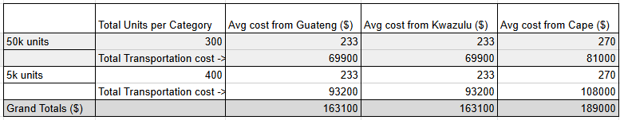

Table 1: Upfront financial estimate to compare site locations. Guateng and Kwazulu have similar estimated transportation costs, while Cape has higher transportation costs

**Financial Breakdown**

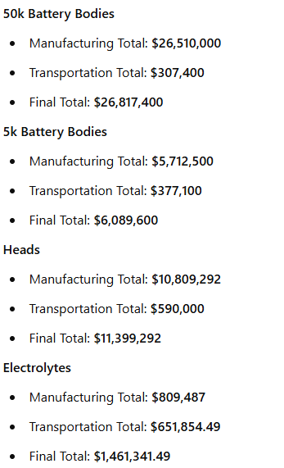

Grand Total : $45,767,633.49

### **References**

Statistics South Africa. (n.d.). *Gauteng provincial economic overview*. Retrieved December 7, 2024, from<https://www.statssa.gov.za/?p=16650>

Wesgro. (2023). *Western Cape economic overview: February 2023*. Retrieved December 7, 2024, from<https://www.wesgro.co.za/uploads/files/Wesgro-Research_Western-Cape-Economic-Overview_2023.02.21.pdf>

Wikipedia contributors. (n.d.). *Economy of the Western Cape*. In Wikipedia. Retrieved December 7, 2024, from<https://en.wikipedia.org/wiki/Economy_of_the_Western_Cape>